TAC Masters Update 14th September 2017

Eridge 10 Mile

Steve Keywood had a very good run at the Eridge 10 where he finished 1st M50 in 16th place and only a few minutes behind his son Jack. Steve has had a few muscle issues this summer so it is great to see him running well as the XC season approaches. M50 Vets team for Kent Vets could be very strong this year.
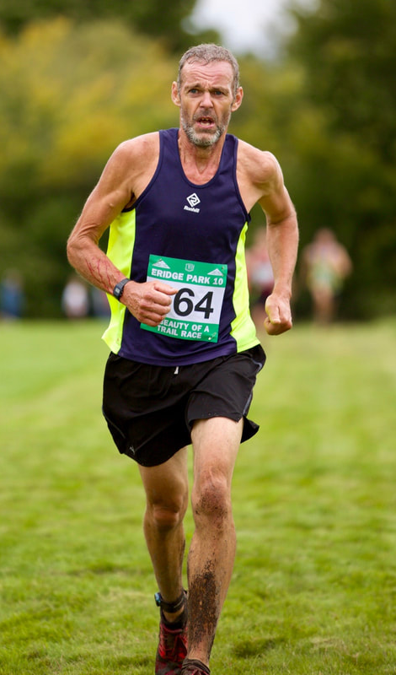
Julian Rendall followed his strong showing on the track at the finals the week before (1500m and 3K) as he showed his adaptability to be second at Eridge and first M40 over what I believe is a true cross country course.
Park Run

Julie Goodge is quietly (until now) continuing her return to competitive running. She ran an impressive 23.25 at Tonbridge Parkrun.
4 Vets travelled to Bromley Parkrun. Adam Roeder achieved his target as he went under 19 mins for the first time in 18.52. Mark PK lowered his 5km best to 18.36 and Richard Tosh also ran a PB of 21.20 finishing one place and 2 seconds behind Lucy PK.
Graeme Saker came 4th in the Rye evening 5Km race in 17.48. It appears that the leading 4 were some way ahead of the rest of the field with Graeme the 1st M50.
https://www.nice-work.org.uk/races/rye-summer-classic-sep/2017
Alan Buckle ran in the Hellingly 10k in 40.22 to be narrowly beaten into officially 2nd M55, although there was a M65 runner who had run 39.58, so 3rd over 55 is correct.
http://www.hailsham-harriers.org.uk/hellingly10k_entry/results_2017.php

The Kent Vets Track events take place this weekend at Erith and I believe that there are a number of TAC athletes competing. We did not have any competing in the jumps last week-end.

It turns out we were very fortunate to have Brigadier John Ridge (or Bridge according to the BBC) competing at the finals. Later that week he was deployed to the Carribean to lead the UK military assistance following Hurrican Irma. He can be seen at http://www.bbc.co.uk/iplayer/episode/b094nczf/victoria-derbyshire-13092017
1.13.20 into the programme.

Vets Track and Field League 2018

Hopefully there will be a SCVAC meeting shortly to discuss the 2018 league season. One of the major issues that needs addressing is the number of teams in the ladies Div 2. I propose that we enter a B team which will give opportunities for people to compete rather than non score. The only issue is that an athlete cannot compete in both A & B teams on the same night. I have asked Sevenoaks AC if they will enter a team and failing that whether up to 5 of their athletes (as per league rules) might like to be second claim members of our B team, with the idea that they enjoy the event and then form their own team for 2019.

Please let me know if you have any points / issues that you would like raised.

B&B relays

The first XC event is this weekend with plenty of vets taking part in the Blackheath and Bromley relays over 4Km each.

South of England Road Relays

This looks like being a good venue within the Crystal Palace site, starting and finishing on the track. For me this will be my first time on the old track!!

Apart Several Senior Mens teams and a couple of senior womens teams, at present we have 1 Ladies M40 vets team, which should do well with Maria, Sasha, Tracey and Lucy. 1.30pm start

Defending our M50 title that we won at Bedford will be tough this year as I expect there will be a strong showing from London Clubs, however it will be interesting to see what we can achieve. It will be good to have a M40 team for the first time in a while, although this will have mixed age groups in it. Look out for e-mails from Mark hookway regarding this event. 2.30pm start for the Men.

Fixtures

We are aware that new members often find it hard to get to grips with the various competitions and which ones they should enter etc. i.e. Kent League, Kent Champs, Kent Vets Champs, Inter counties etc To help with understanding these races Alan Newman has worked hard at putting together a Vets specific fixture list with explanations as to how entries are made and who can compete in local, regional, National and International competitions. The idea is for this to be “live” so additions will be continuously added and it will be posted on the Masters section of http://www.tonbridgeac.co.uk/Masters/masters_fixtures.html

Please let him know if you intend to do a particular race and would like it posted on the list, which will help to get team mates involved.
mranewman@sky.com

